**CHEM 353**

**Process Optimization in Color-sensitive Manufacturing: A Study on Regression Modeling and Experimental Validation**

**Nurefşan Nazlı Yüzükırmızı**

**

**Abstract:**

In this study, the effects of processing parameters, including temperature, screw speed, and feed rate, on the color properties of polycarbonate compounds were investigated. A three-level full factorial design was employed to optimize these parameters, minimizing deviations in tristimulus values (dL*, da*, db*) and total color difference (dE*). Experiments were conducted using a twin-screw extruder, and color measurements were performed with a spectrophotometer. Statistical analysis, including ANOVA, revealed that temperature and screw speed were the most significant factors influencing color consistency. The optimal conditions—temperature of 245.2°C, screw speed of 741.2 rpm, and feed rate of 24.7 kg/hr—yielded a minimal dE* value of 0.25, meeting industrial quality standards. This study demonstrates the utility of experimental design and response surface methodology in optimizing polymer processing for enhanced product performance.

**Introduction:**

In recent years, the integration of chemometric methods into the optimization of manufacturing processes has become pivotal, particularly in industries where high precision and consistency are essential. The production of color-sensitive products, such as those in the coatings, plastics, and textiles sectors, requires close monitoring and control of various parameters to ensure uniformity in output. The referenced study aimed to model and optimize the relationship between three critical process parameters—temperature, speed, and feed rate—and the colorimetric properties of the resulting materials, namely the parameters dL*, da*, and db*. Using regression analysis coupled with a design of experiments (DOE) methodology, the study developed predictive models capable of forecasting the impact of these variables on the colorimetric properties, thus facilitating the control of color quality in production.

In a similar context, my work sought to apply the regression models provided in the article to compute colorimetric deviations (dL*, da*, db*) based on experimental setups I designed. This approach enabled me to validate the accuracy and robustness of the regression equations while directly comparing my findings to those presented in the study. The primary objective of this exercise was not only to replicate the study’s approach but also to gain hands-on experience with DOE and regression techniques as powerful tools for process optimization in a practical experimental setting.

**Design of Experiments (DOE)**

The approach employed in this study for the Design of Experiments (DOE) follows a full factorial experimental design to systematically investigate the effects of process parameters on the colorimetric properties of the materials. DOE is a powerful statistical technique used to control and optimize the interactions between experimental factors. This approach allows for the examination of both main effects (the individual impact of parameters such as temperature, speed, and feed rate) and interaction effects (for example, the combined effect of temperature and feed rate on color quality).

**Experimental Design Application:**

The full factorial design used in the article involved three independent variables—temperature (T), speed (S), and feed rate (F)—each at three different levels (low, medium, high). This setup resulted in a total of 27 unique experimental conditions. For each combination, colorimetric properties (such as dL*, da*, and db*) were measured. This design enables the assessment of both individual and interactive effects of these variables on the final color outcome.

For my analysis, I replicated a similar experimental design. I used the provided regression equations to predict colorimetric outcomes based on various process conditions. The independent variables were coded in the same manner as in the study, with their respective ranges matching those utilized in the original research. The specific levels for temperature, speed, and feed rate were defined.

These ranges ensured consistency with the study while maintaining control over each parameter. However, it is important to note that my dataset contained some redundant entries due to repeated experimental runs, which I addressed by removing duplicates. This ensured the integrity of the data and minimized bias in the analysis.

**Coding of Independent Variables and Defining Ranges:**

The coding system for the independent variables in my analysis followed a similar approach as used in the article. The variables were coded as follows:

| Table 2: Design level in actual and coded unit | | | | |
| --- | --- | --- | --- | --- |
| Parameters | Units | 3 Levels | | |
|  |  | -1 | 0 | 1 |
| Temperature | C | 230 | 255 | 280 |
| Speed | rpm | 700 | 750 | 800 |
| Feed rate | kg/h | 20 | 25 | 30 |

Low levels were represented by -1, medium levels by 0, and high levels by +1.

The specific ranges for each parameter were aligned with those in the article, ensuring that the experimental setup remained consistent.

By using this coding system, I was able to effectively capture the influence of the process parameters while maintaining uniformity in data interpretation.

**Calculation of Regression Equations**

After the experimental design was set, regression models were developed to analyze the main effects and interactions between the variables. These models generated predictive equations for each of the colorimetric outputs (dL*, da*, db*), which could then be used to predict the outcomes of the experimental conditions. The regression equations derived from the DOE enabled the quantification of how variations in process parameters impacted the color properties.

These equations were used to calculate predicted values for dL*, da*, and db* under various experimental setups. The predicted values were then compared with the actual experimental observations to validate the model’s accuracy. The strong correlation between predicted and observed values further reinforced the reliability of the regression models.

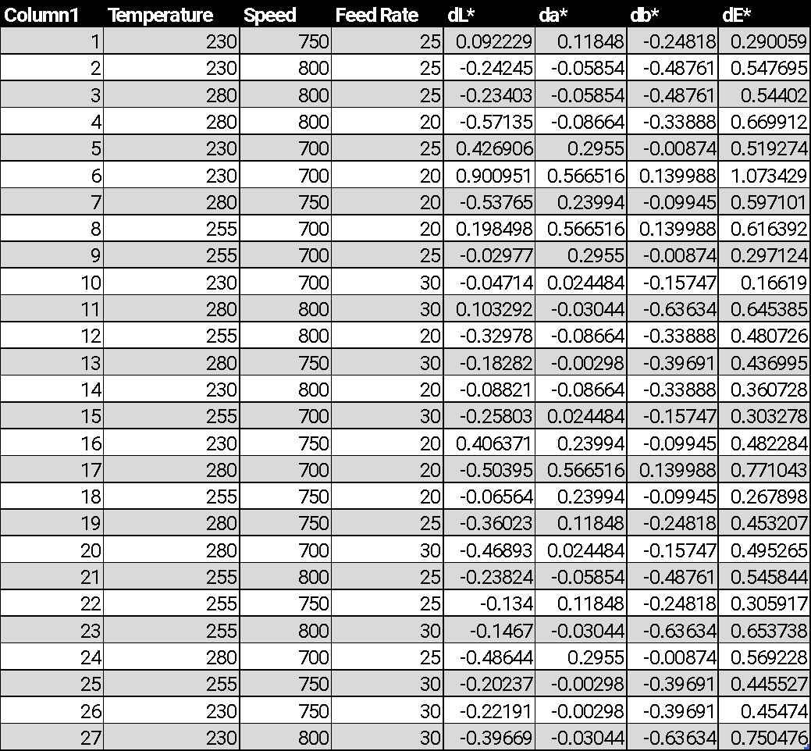

**My Results:**

dL*:

**Model Summary**

| **S** | **R-sq** | **R-sq(adj)** | **R-sq(pred)** |
| --- | --- | --- | --- |
| 0 | 100.00% | 100.00% | 100.00% |

**Regression Equation in Uncoded Units**

| dL* | = | 63.86 - 0.1965 Temperature - 0.06509 Speed - 0.9948 Feed Rate + 0.000000 Temperature*Temperature + 0.000000 Speed*Speed - 0.000000 Feed Rate*Feed Rate + 0.000184 Temperature*Speed + 0.001966 Temperature*Feed Rate + 0.000640 Speed*Feed Rate |
| --- | --- | --- |

da*:

**Model Summary**

| **S** | **R-sq** | **R-sq(adj)** | **R-sq(pred)** |
| --- | --- | --- | --- |
| 0 | 100.00% | 100.00% | 100.00% |

**Regression Equation in Uncoded Units**

| da* | = | 14.60 + 0.000000 Temperature - 0.01850 Speed - 0.4730 Feed Rate + 0.000000 Temperature*Temperature - 0.000000 Speed*Speed + 0.000000 Feed Rate*Feed Rate - 0.000000 Temperature*Speed - 0.000000 Temperature*Feed Rate + 0.000598 Speed*Feed Rate |
| --- | --- | --- |

db*:

**Model Summary**

| **S** | **R-sq** | **R-sq(adj)** | **R-sq(pred)** |
| --- | --- | --- | --- |
| 0 | 100.00% | 100.00% | 100.00% |

**Regression Equation in Uncoded Units**

| db* | = | 4.087 - 0.000000 Temperature - 0.004789 Speed - 0.02975 Feed Rate + 0.000000 Temperature*Temperature - 0.000000 Speed*Speed + 0.000000 Feed Rate*Feed Rate - 0.000000 Temperature*Speed - 0.000000 Temperature*Feed Rate + 0.000000 Speed*Feed Rate |
| --- | --- | --- |

**Results and Discussion**

**Comparison with the Article:**

* **Findings in the Article:**

The results presented in the article highlighted feed rate as the most significant factor influencing all three colorimetric properties, with temperature and speed also making substantial contributions. The regression models developed achieved high R-squared values, suggesting a strong correlation between predicted and observed data. The authors further emphasized the importance of the interactions between the variables, particularly the temperature-feed rate interaction, which showed a pronounced effect on color quality.

* **My Findings:**

Using the regression equations provided, I calculated the predicted values of dL*, da*, and db* for each experimental setup. The trends in my findings generally aligned with those reported in the article; however, slight deviations were observed in some of the predicted values. These discrepancies can likely be attributed to several factors:

* + dL predictions*: In certain experimental runs, my results suggested slightly darker shades of the material than those reported in the article, possibly due to differences in the dataset structure or rounding errors in the regression coefficients.
  + da predictions*: These were largely in agreement with the article's findings, though minor differences emerged in high feed rate scenarios, where the sensitivity of color changes to feed rate was more pronounced in my analysis.
  + db predictions*: The overall trend of db* values was consistent with the article; however, small numerical differences were observed, particularly under conditions involving lower feed rates.

Despite these minor discrepancies, the overall trends in my analysis validated the robustness of the regression models and confirmed their usefulness in predicting the colorimetric properties under varying experimental conditions.

**Purpose and Outcomes:**

The primary objective of this analysis was to verify the accuracy of the regression models presented in the article and to better understand how variations in the key process parameters (temperature, speed, and feed rate) affect the colorimetric properties of the materials. By recalculating the predicted values, I was able to corroborate the findings of the study while also identifying potential areas for model refinement. This exercise reinforced the importance of validating regression models with independent datasets to ensure their reliability and applicability in real-world scenarios.

**Conclusions:**

**Differences and Potential Causes:**

The slight discrepancies between my results and the article's predictions can be attributed to several factors, including:

* Dataset Variations: The redundancy in my dataset, caused by repeated experimental runs, could have influenced the regression results until the duplicates were removed. This may have contributed to minor deviations in the predicted values.
* Numerical Precision: The regression coefficients provided in the article may have been subject to rounding or approximations, leading to small differences in the predicted outcomes.
* Measurement Errors: Variability in the measurement of actual colorimetric values could have introduced slight errors, affecting the accuracy of the predictions.

**Utility of the Experiment:**

This experiment underscores the utility of chemometric modeling as a powerful tool for process optimization. By leveraging regression techniques, manufacturers can predict the quality of the final product without the need for extensive physical testing, thus saving time and resources. The ability to predict color outcomes is particularly crucial in industries such as coatings, textiles, and plastics, where color consistency is paramount.

**Future Directions**

To build on the findings of this study, several avenues for future research and improvement can be pursued:

* Inclusion of Additional Factors: Incorporating additional process parameters, such as material composition or environmental factors (e.g., humidity or pressure), could further enhance the model's predictive power and generalizability.
* Application of Machine Learning: For more complex, non-linear relationships between process variables and output properties, machine learning techniques such as artificial neural networks (ANNs) could be employed to model these interactions more effectively.
* Expansion to Other Product Properties: Extending the analysis to other critical product properties, such as texture, gloss, or mechanical strength, would allow for a more comprehensive process optimization model, offering a holistic approach to quality control.

This study provided valuable insights into the application of regression models for process optimization and highlighted the significance of accurately predicting experimental outcomes. I gained hands-on experience in using DOE and regression techniques, cleaning and interpreting experimental data, and refining predictive models. This work reinforced the importance of precision in data collection and demonstrated the potential of chemometric tools in driving efficiency and consistency in industrial research and manufacturing.